CANDIDATE NAME

CLASS INDEX NUMBER


RAFFLES INSTITUTION (JC)
PRELIMINARY EXAMINATION 2009

HIGHER 1

CHEMISTRY 8872/02
Paper 2 23 September 2009
2 hours
Candidates answer Section A on the Question Paper
Additional Materials: Answer Booklet/ Paper
Data Booklet
Graph Paper

READ THESE INSTRUCTIONS FIRST
Do not open this question booklet until you are told to do so.
Write your name, class and index number in the spaces provided on the cover page.
Write in dark blue or black pen on both sides of the paper.
You may use a soft pencil for any diagrams, graphs or rough working.
Do not use paper clips, highlighters, glue or correction fluid.

Section A
Answer all questions.

Section B
Answer any two questions on separate answer paper.

At the end of the examination, fasten all your work securely together.
The number of marks is given in brackets [ ] at the end of each question or part question.

For Examiner’s Use
Section A
B6
B7
B8
Total


This document consists of 15 printed pages.
Raffles Institution
Junior College

Section A (40 marks)
For Examiner’s Use

This section consists of 5 questions.
Answer all questions in the spaces provided.

1. | Hydrazine is a hydride of nitrogen with the formula N₂H₄. It is a colourless liquid with an ammonia-like odour and is derived from the same industrial chemistry processes that manufacture ammonia. However, hydrazine has physical properties that are more similar to water. It can behave as a weak monoacidic base, forming salts with the more common mineral acids, like sulfuric acids.  Hydrazine is a strong reducing agent. Warming hydrazine with nitric acid results in the reduction of nitric acid to nitrogen monoxide, NO while hydrazine is oxidised to nitrogen, N₂. A variant of hydrazine, methylhydrazine CH₃NHNH₂, when mixed with dinitrogen tetraoxide, N₂O₄, is used as a rocket fuel as this gives a highly exothermic reaction.
 | (a) | Draw a dot-and-cross diagram for hydrazine. State the shape for the hydrazine molecule around the nitrogen atom and the bond angle of H−N−H.
 |  |  | [3]
 | (b) | Hydrazine can react with sulfuric acid to give a salt, hydrazine sulfate, (N₂H₅⁺)(HSO₄⁻). Explain, with the aid of an equation, if an aqueous solution of hydrazine sulfate is acidic, neutral or basic.
 |  | [2]
 | (c) | Write a balanced equation for the reaction of nitric acid with hydrazine.  For Examiner’s Use
 |  |  | [1]
 | (d) | The equation between methylhydrazine and dinitrogen tetraoxide may be represented by:  4CH₃NHNH₂(l) + 5N₂O₄(l) ⎯→ 4CO₂(g) + 9N₂(g) + 12H₂O(l)  By using the enthalpy changes of formation given below, calculate the enthalpy change of the reaction.
   | ΔH_{f} / kJ mol⁻¹
  CH₃NHNH₂(l) | +53
  N₂O₄(l) | −20
  CO₂(g) | −394
  H₂O(g) | −242
 |  |  | [2]
 | (e) | Diphosphine, P₂H₄, is the phosphorus analogue of hydrazine. Explain why diphosphine is predicted to have a lower boiling point as compared to hydrazine.  For Examiner’s Use
 |  |  | [2]
 | (f) | Hydrazine is used in Wolff-Kishner reduction, a reduction that transforms the carbonyl group of a ketone or aldehyde into a methylene (−CH₂) group via a hydrazone intermediate. A reaction scheme is shown below:  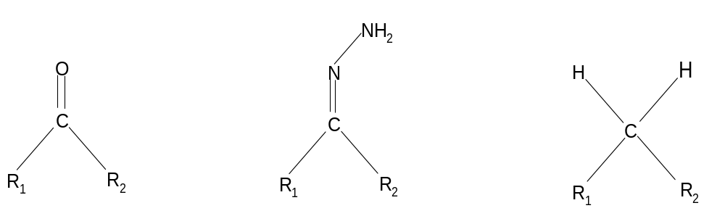  KOH  Step II  N₂H₄  Step I  With reference to the reaction scheme given in the Wolff-Kishner reduction, draw the structure of the carbonyl compound which can give the alkane product as shown:  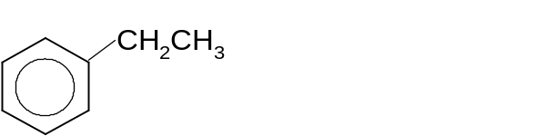  State the type of reaction in Step I.
[2]
[Total: 12]
For Examiner’s Use
2. | The graph shows the logarithm, lg, of the ionization energies for the outermost seventeen electrons in an atom of an element X in Period 4.  0 5 10 15  Number of electrons removed  0  1  2  3  4  5  lg I.E.
 | (a) | (i) | From the graph above, deduce the group in the Periodic Table to which X is likely to belong to. Explain your reasoning and suggest an identity for element X.
 |  | (ii) | Suggest, with the aid of an equation, the pH of the resulting solution of the reaction of the oxide of X with water.
 |  |  | [5]
 | (b)  0 | Complete the sketches for elements of the third period (sodium to chlorine) to show how each property changes along the period  For Examiner’s Use  Electrical Conductivity  Na Mg Al Si P S Cl  Ionic radius  Na Mg Al Si P S Cl
[2]
[Total: 7]

3. | (a) | Define the term ‘standard enthalpy change of neutralisation’.  [1]
 | (b) | When 30.0 cm³ of 0.40 mol dm⁻³ of barium hydroxide were mixed with 40.0 cm³ of 0.80 mol dm⁻³ hydrochloric acid in a polystyrene cup, the temperature of the solution rose by 4.0 °C. Assume that 4.3 J are required to raise the temperature of 1 cm³ of solution by 1.0 °C. 0.80 mol dm⁻³ hydrochloric acid in a polystyrene cup, the temperature of the solution rose by 4.0 °C. Assume that 4.3 J are required to raise the temperature of 1 cm³ of solution by 1.0 °C.
 |  | (i) | Calculate the enthalpy change of neutralisation for the above reaction.
 |  | (ii) | Suggest why the value in (b)(i) deviates from the theoretical value of −57.3 kJ mol⁻¹.  For Examiner’s Use
 |  |  | [5]
 | (c) | The decomposition of hydrogen peroxide is a first order reaction.  H₂O₂ → H₂O + ½O₂ ∆Hº = −98 kJ mol⁻¹  The uncatalysed reaction has an activation energy of +79 kJ mol⁻¹.
 |  | (i) | Sketch and label an energy profile diagram for the uncatalysed reaction, showing all relevant energy changes.
 |  | (ii) | The enzyme, catalase, can be used to speed up the reaction. Define the term enzyme and explain briefly how it can speed up the reaction.  For Examiner’s Use
[4]
[Total: 10]

4. | (a) | Phenyl-4-methoxycinnamate, A, is used in various sun-tan creams to absorb excessive ultraviolet radiation.  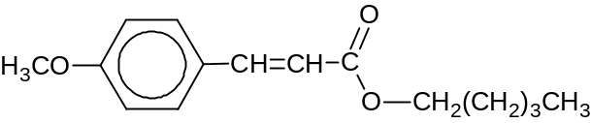  A  Explain why A is able to exhibit geometric isomerism.
 |  | [2]
 | (b) | Compound B can be synthesised from the naturally occurring amino acid phenylalanine by the following route:  For Examiner’s Use
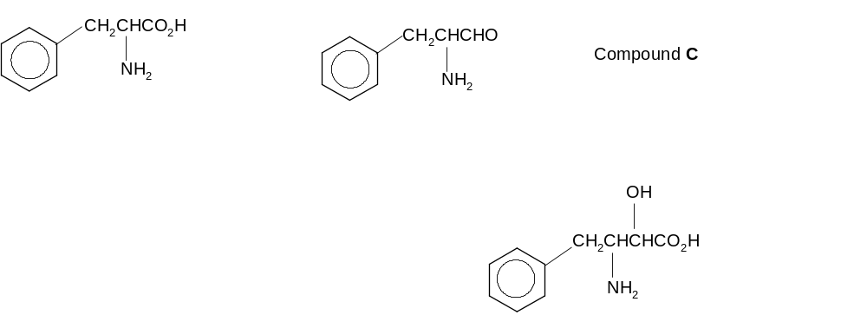
Step I
Step II

HCN
Step III
Compound B
 |  | (i) | Suggest the type of reaction in step I.
 |  | (ii) | Draw the structure of the intermediate compound C.
 |  | (iii) | State why a trace amount of base is required to speed up the reaction in step II.
[3]
[Total: 5]

5.  For Examiner’s Use | Compound X has the following structure:  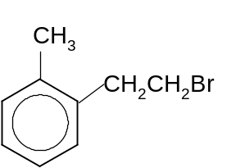  Compound X
 | (a) | Suggest a 3-step reaction scheme to convert compound X to the compound as shown below. You need to state clearly the reagents and conditions required and the intermediates that are formed.  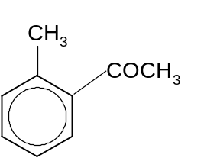
 |  | [5]
 | (b) | An alkyl group can be substituted into a benzene ring by using the method of Friedel-Crafts alkylation as shown:  For Examiner’s Use  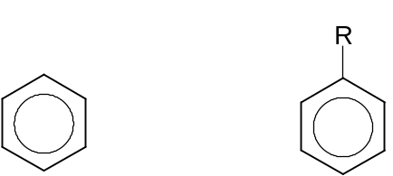  FeBr₃  RBr +  + HBr  Propose a reaction scheme to convert X to the compound as shown below:  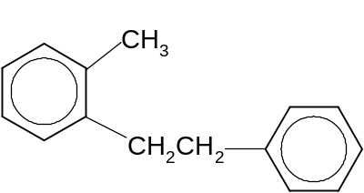
 |  |  | [1]
 |  |  | [Total: 6]

Section B (40 marks)

This section consists of 3 questions.
Answer any 2 questions from this section.
Begin each question on a fresh sheet of paper.

6. | (a) | The diagram below shows a Born-Haber energy cycle for the ionic compound, NaCl.  Na(s) + ½Cl₂(g) NaCl(s)  ΔH₁  Na(g) + Cl(g)  Na⁺(g) + Cl⁻(g)  ΔH₂  ΔH₃  ΔH₄  ΔH₅  Lattice energy of NaCl(s)
 |  | (i) | Based on the energy cycle given and the data given below, calculate the lattice energy of NaCl.
  ΔH₁ | = −776 kJ mol⁻¹
  ΔH₂ | = +109 kJ mol⁻¹
  ΔH₃ | = +244 kJ mol⁻¹
  ΔH₄ | = +494 kJ mol⁻¹
  ΔH₅ | = −364 kJ mol⁻¹
 |  | (ii) | What enthalpy terms are represented by ΔH₁ and ΔH₄ respectively?
 |  | (iii) | How would the lattice energy of MgCl₂ compare with that of NaCl? Explain your answer clearly.
 |  |  | [6]
 | (b) | A compound P contains C, 35.0%; H, 6.6% and Br, 58.4% by mass. The relative molecular mass of P is 136.9. Treatment of P with warm aqueous sodium hydroxide gives Q, which on oxidation gives R. R forms an orange precipitate with 2,4-dinitrophenylhydrazine, and both Q and R on treatment with aqueous alkaline iodine, give a yellow precipitate. When P is treated with ethanolic sodium hydroxide it forms three isomeric compounds, V, W and X, each of which, on treatment with HBr, is converted back to P.  Deduce, with reasoning, the structures of compounds P, Q, R, V, W, and X.
 |  |  | [10]
 | (c) | Suggest simple chemical tests by which the following pairs of compounds can be distinguished from each other. You should state the reagents and conditions for each test and the observations that would distinguish one compound from the other.
 |  | (i) | 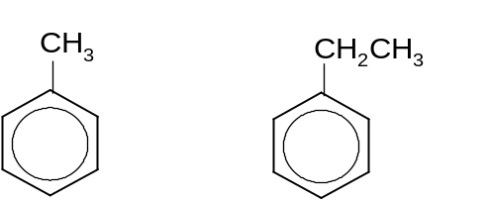
 |  | (ii) | 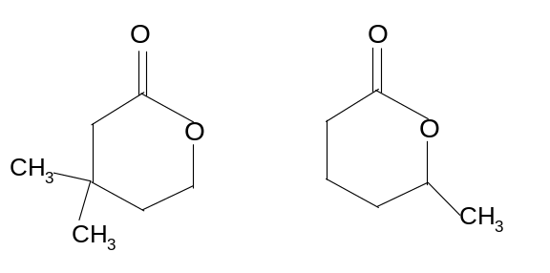
[4]
[Total:20]
7. | (a) | Many of the chemical reactions that occur in living systems are extremely sensitive to  pH. As a result, the human body maintains a remarkably intricate system of buffers, both within tissue cells and in the fluids that transport blood cells. Blood is one of the most prominent examples of a buffer in the human body. The major buffer system that is used to control the pH of blood is the carbonic acid hydrogen carbonate buffer system.  H₂CO₃(aq) 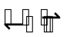 HCO₃⁻ (aq) + H⁺ (aq)
 |  | (i) | What do you understand about the term ‘weak acid’?
 |  | (ii) | Write an expression for the K_{a} of carbonic acid, giving its units.
 |  | (iii) | Explain, with the aid of equations, how the buffer system in blood helps to control pH.
 |  | (iv) | The pH of human plasma is usually maintained at about 7.4. By using the expression of K_{a} in (a)(ii), calculate the ratio of the concentration of hydrogen carbonate ion and carbonic acid in plasma, given the K_{a} of carbonic acid is 7.94 × 10⁻⁷ mol dm⁻³.
 |  | (v) | Will the ratio of the concentrations of hydrogen carbonate ion and carbonic acid in plasma change when the body temperature is increased? Explain your answer.
 |  |  | [7]
 | (b) | (i) | State and explain the trend of melting points of the elements across the third period from Na to Ar.
 |  | (ii) | Gallium oxide is used as a semi-conductor in the electronic industry. State the structure of this oxide. Would you expect gallium oxide to be acidic, basic or amphoteric? Write suitable equation(s) to illustrate your answer.
 |  |  | [10]
 | (c) | A chloride of Group V element has the formula MCl₃. When 0.100 g of MCl₃ was added to water and the resulting solution titrated with 0.0500 mol dm⁻³ silver nitrate, it was found that 33.00 cm³ of aqueous silver nitrate was needed to precipitate all the chloride ions. Use these data to calculate the A_{r} of M and hence identify M.
[3]
[Total: 20]

8. | (a) | The following reaction scheme shows the synthesis of the compound, P, starting from chloroethane:  CH₃CH₂OH  CH₃CH₂COOH  P  CH₃CH₂Cl  Stage I
 |  | (i) | State the type of reaction occurring in stage I, and suggest the reagents and conditions required.
 |  | (ii) | Show how CH₃CH₂COOH can be prepared from CH₃CH₂Cl, including the structure(s) of any intermediate(s) formed.
 |  | (iii) | Compound P can be formed from the reaction between ethanol and propanoic acid. Draw the structure of compound P, and suggest the reagents and conditions required.
 |  | (iv) | State and explain the difference in the acid strengths of CH₃CH₂OH and CH₃CH₂COOH.
 |  |  | [10]
 | (b) | Chlorofluorocarbons (CFCs) pose environmental problems in that they cause the depletion of the ozone layer. Due to their stability, the chlorofluorocarbons that are released into the atmosphere do not break down and they eventually find their way into the upper atmosphere. When they reach the ozone layer, a series of complex reactions takes place.  CFC molecules are broken down into chlorine radicals (Cl•) and other molecular fragments through homolytic bond fission when they absorb ultraviolet light. For example,  CCl₂F₂ ⎯→ •CClF₂ + Cl•
 |  | (i) | State one use of CFCs.
 |  | (ii) | Suggest why the C−Cl bond is broken to form chlorine atoms instead of the C−F bond being broken to form fluorine atoms.
 |  | (iii) | It is known that one CFC molecule can destroy literally thousands of ozone molecules. Suggest a reason for this, with reference to the information given above.
 |  |  | [3]
 | (c) | Aqueous benzenediazonium chloride, C₆H₅N₂Cl, decomposes according to the equation:  C₆H₅N₂Cl(aq) + H₂O(l) ⎯→ C₆H₅OH(aq) + N₂(g) + H⁺(aq) + Cl⁻(aq)  The rate of the reaction can be followed by measuring the volume of nitrogen evolved at different times. The following results were obtained:
  Time/ min | Volume of N₂/ cm³
  0  4  7  14  21  25  ∞ | 0  54  87  139  172  184  220
 |  | (i) | By plotting a graph of volume of nitrogen gas evolved against time, find the order of reaction with respect to benzenediazonium chloride.
 |  | (ii) | In this experiment, the kinetics appear to be zero order with respect to water. Suggest a reason for this.
 |  | (iii) | Calculate the mass of benzenediazonium chloride used in the above reaction, assuming room temperature and pressure conditions.
[7]
[Total: 20]

